A-Level Biology – Year 2
Summer Task
What will be expected off you on your return………
Expectations when you arrive …….
It is imperative that you are organised when you arrive next year, one basic requirement when undertaking this course is that you are methodical and ALL notes are arranged in order. Your notes will be regularly checked next year by your teachers; ensuring notes are being made during home study. In order to help you achieve this, you should all attend your first lesson with a folder. Many students opt for the ring binder style (as many notes will be made), but if you have an alternative idea that will allow your notes to be organised then great.
Optional: You will need the A Level textbook once you start your studies however this is expensive and you may wish to purchase from school we can get it at a discounted price, although you may be able to get a copy from outgoing year 13s.
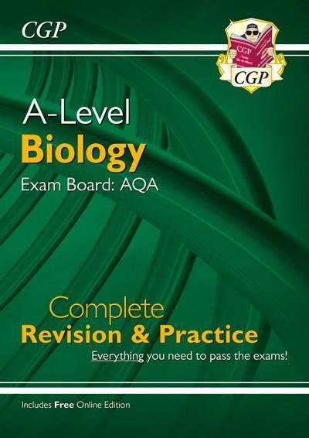
Recommended:

A-Level Biology: AQA Year 1 & 2 Complete Revision & Practice with Online Edition
- Product code: BAR73
- ISBN: 9781789080261

Task: Revision for Mass Transport end of topic test & Biodiversity end of topic test
Your task is to revise for the above 2 assessments. A reminder of the content on the tests is on the table on the next page. We recommend you use your google classroom, PMT, Carousel, Save my exams, Seneca and/or Cognito to prepare. Remember – active revision (actively testing yourself with questions) is better than passive revision (reading and taking notes)..

Below is the list of topics that will be covered in the 2 tests.
Revision for Mass Transport Test:
Haemoglobin
Transport of oxygen by haemoglobin
Circulatory system of a mammal
The structure of the heart
The cardiac cycle
Blood vessels and their functions
Transport of water in the xylem
Transport of organic molecules in the phloem
Investigating transport in plants
Revision of Biodiversity Test:
Species and taxonomy
Diversity within a community
Species diversity and human activity
Investigating diversity
Quantitative investigations of variation

Biology Enhancement Tasks
1. Read books
To be a better biologist it helps to see biology in its wider context, and as it’s blinking interesting, to look in more detail at some areas of biology that you may currently know very little about. These books are a fantastic springboard into the wonder of biology and they are written at a level that assumes very little about your prior subject knowledge, but reading them will stretch you into areas that go beyond university level.
The Emperor of All Maladies: A Biography of Cancer is a book written by Siddhartha Mukherjee, an Indian-born American physician and oncologist.
Charles Darwin’s On The Origin of Species, in which he writes of his theories of evolution by natural selection, is one of the most important works of scientific study ever published.
The Selfish Gene is a 1976 book on evolution by ethologist Richard Dawkins, in which the author builds upon the principal theory of George C. Williams's Adaptation and Natural Selection.
2. Read online
https://www.rsb.org.uk/biologist
https://www.nature.com/
https://www.newscientist.com/
https://www.bmj.com/student
https://catalyst-magazine.org/
3. Watch online videos
https://www.youtube.com/user/amoebasisters We are two sisters on a mission to demystify science with humor and relevance by creating videos, GIFs, comics, and resources. Our content is focused on high school biology (Pinky is a former high school biology teacher), though we do receive comments that some of our content is useful for intro biology courses at the college level as well. We're for anyone wanting to learn biology!
https://www.youtube.com/@kurzgesagt Animation videos explaining things with optimistic nihilism since 12,013. We’re a team of illustrators, animators, number crunchers and one dog who aim to spark curiosity about science and the world we live in. To us nothing is boring if you tell a good story.
https://www.youtube.com/@SciShow SciShow explores the unexpected. We delve into the scientific subjects that defy our expectations and make us even more curious!

