1.6 (a) Natural fibres

Natural fibres are made from plant or animal sources such as cotton, linen and wool.
Any flexible fabric that is made from fibres is classified as a textile. It consists of a network of thin thread-like fibres which are combined in a number of ways such as woven, nonwoven and knitted. You need to know about two types of fibres.

Cotton
Cotton is a natural fibre that is produced from cotton plants that grow in tropical climates where the soil is wet. The cotton fibres come from cotton bolls that form after the cotton flower has died. To produce the cotton fibres firstly the boll has all of the seeds, stalks and leaves removed during a process called ‘ginning’. The cotton is then sent to mills to be carded, which uses brushes to draw out the cotton into a thin film which in turn is then drawn into slivers. This process is repeated until the fibres are very fine when they are spun into twisted thread. These threads can be used for sewing or can be woven in to a fabric. Cotton is a versatile fabric and can be used for clothing, towels, and even used for hard wearing materials such as denim. Since cotton can have lots of different types of finish applied to it, care is needed when washing; this is addressed by using specific instructions on the care labels attached to clothing.

Linen
Linen is a strong fabric that is woven from fibres produced from flax. Flax is a plant that grows in cool damp climates, mostly in the northern hemisphere. To produce the fibre flax plants are harvested then laid out in fields for a number of weeks to allow micro-organisms to attack the gum that holds the fibre to the stem. The flax is then processed through gathering, drying and scutching (a rolling and scraping process) to obtain the fibres. Fibres that are 30cm to 50cm long are then spun into yarn which can then be used to produce linen.
Linen is an expensive fabric and has a smooth texture that is produced by calendering with heavy rollers. Linen is available in a range of weights, with light weight linen such as lawn and cambric being used for shirts and blouses, whilst heavier weights can be used for embroidery. Linen absorbs water well which makes it ideal for tea towels and bed linen.

Wool
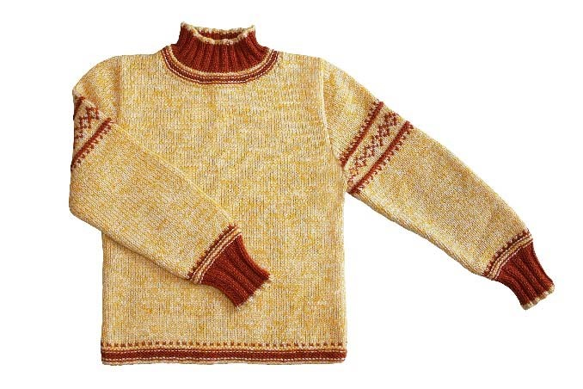
Most wool that is used in the production of clothing and fabrics comes from the fleece of sheep, although hair from camels, llamas, goats and angora rabbits are also used. In order to be used the wool first needs to be washed. It then goes through a process called carding that brushes the wool. Wool has short fibres can be used for two types of cloth - worsted and woollen. Worsted fabric is produced from fibres that are combed to make them all parallel resulting in an even texture. This produces a high quality yarn that is used for fine cloths such as gabardine and barathea.
Wool yarn is produced from very short fibres which run in lots of different directions - this is why wool feels fluffy. It also helps to keep air trapped that in turn means wool is warm to touch and can be used for clothing that is a good insulator. Wool is spun into different types of yarns including various thicknesses for knitting (ply), or for weaving.

 | Properties | Disadvantages | Applications
Cotton | - Good conductor of heat  - Absorbs water well  - Able to be dyed or printed on  - Strong and hard wearing | - Creases easily  - Flammable  - Damaged by exposure to sunlight | - Sewing  - Clothing  - Denim
Linen | - Withstands high temperature  - Good conductor of heat  - Absorb water well | - Creases easily  - Difficult to dye  - Frays easily  - expensive | - Shirts  - Blouses  - Lace  - Embroidery  - Bed linen
Wool | - Warm  - Resilient  - High absorbency  - Able to be dyed | - Can shrink when washed at high temperatures  - Easy to scorch  - More expensive than synthetic fibres | - Knitting wool  - Clothing, including flannel, cashmere, tweed

1.6 (b) Manmade Fibres

Manmade fibres are made from coal, oil or petrol based chemicals such as nylon, polypropylene, and polyester.

Nylon
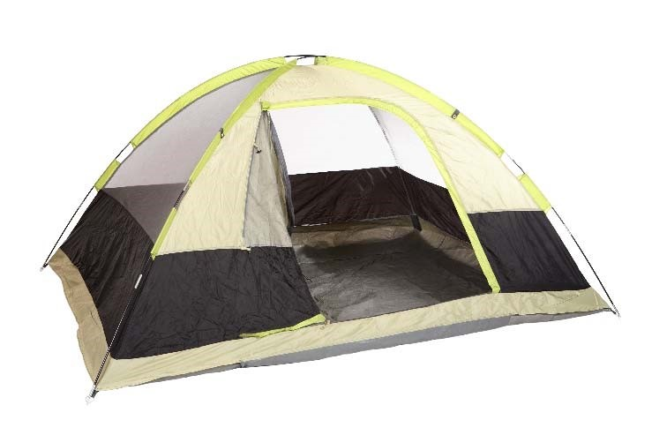
Nylon forms as a long filament when it is produced, although this can be cut into short fibres. These fibres are very light and smooth with some silk like properties and importantly good strength. These properties make nylon a very useful fibre to work with and can be woven into a very close weave making it windproof and water repellent. There are two types of nylon, nylon 6 and nylon 6.6 - these are produced using different methods, nylon 6 through a chemical reaction and nylon 6.6 is produced from a single compound. These two types of nylon have slight differences, however both tend to be produced from oil.

Polypropylene
Polypropylene is the lightest of all synthetic fibres which means that it is good for clothing that needs to provide warmth without adding excessive weight. It also retains heat well and does not absorb liquids easily making it ideal for outdoor clothing, often being considered to be warmer than wool. Unlike other synthetic manmade fibres polypropylene does not generate static electricity

Polyester
Originally known by the name Terylene, polyester was developed in the 1950s as a byproduct of the petrochemical industry. Polyester can be easily dyed which is one of the reasons why it is popular in the fashion industry. Furthermore it is resistant to shrinkage, wrinkling and stretching which makes it very easy to look after, whilst its quick drying properties make it a good choice for clothing that will be worn outdoors. Polyester can feel silky to the touch and fabrics can be produced by weaving or knitting which makes it a versatile alternative to natural fibres. Polyester is a synthetic material which mostly comes from non-sustainable sources, although increasingly plastic bottles are being recycled to produce polyester fabric.

 | Properties | Disadvantages | Applications
Nylon | - Excellent abrasion resistance  - Range of finishes are possible  - High levels of durability  - Lightweight | - Low absorbency  - Can shrink  - Poor resistance to UV light  - Can create static | - Clothing  - Carpets  - Parachutes, umbrellas and kites  - Rope  - Stockings
Polypropylene | - Moth proof  - Lightweight  - Good abrasion resistance  - Very good chemical resistance  - Quick drying  - Resistant to staining | - Cannot be dyed once it is spun  - Specialist dry cleaning is required  - Poor resistance to UV light | - Ropes  - Luggage  - Table cloths  - Face masks
Polyester | - Good strength  - Resists rubbing  - Polyester is easy to care for and resists creasing and stretching  - Resistant to chemicals, mould, rot and sunlight | - Non-absorbant  - Does not feel warm to wear  - Needs a hot iron to remove creases  - Causes static electricity to build up | - Often mixed with cotton for clothing  - Car seat belts and safety belts  - Duvet and pillow fillings  - Sportswear  - Non-iron fabrics

1.6 (c) Textile treatments – flame resistant, polytetrafluoroethylene (PTFE)

Flame resistant
Although many natural fibres have some flame resistant properties the same cannot be said for synthetic fibres. As a result there is a growing need for textiles to be treated to increase their fire resistance. There are a number of different ways in which textiles can be made flame resistant; one method involves using phosphine gas, formaldehyde and a mineral acid such as hydrochloric acid.
Flame resistant treatments slow down the combustion process at different stages such as heating, ignition or spreading of flame. Different treatments are used depending on the type of fabric and the application that it is used for be that furniture, soft furnishings or clothing. Some flame resistant treatments deteriorate when they come into contact with liquids so they need to have specialist cleaning otherwise they will need to have the treatment reapplied time and time again.

Polytetrafluoroethylene (PTFE)
Polytetrafluoroethylene (PTFE) can be used for many different applications, however for textiles it often used to provide a protective surface to a fabric. This can result in a fabric that does not stain or get damaged by spills. PTFE works well on wool and cotton and does not change its look, feel or colour. PTFE can be used to apply a protective coating to clothing, upholstery, bedding and indoor furnishings. When a liquid is spilt on to a fabric that has been treated it tends to form into droplets that can then roll off or be wiped up easily – the PTFE coating prevents the liquid from soaking in.

