Year 13 Transition work 2025

You need to read No et Moi by Delphine De Vigan in English over the summer. You could also start reading the French version.
Think about the key themes that are treated in the book. To what extent is the setting important?
Distinguish between main and secondary characters.
Compare two of the characters in terms of their role in the narrative. Compare their backgrounds.
To what extent do you think the characters share a common goal or purpose?
Do you have a favourite character?
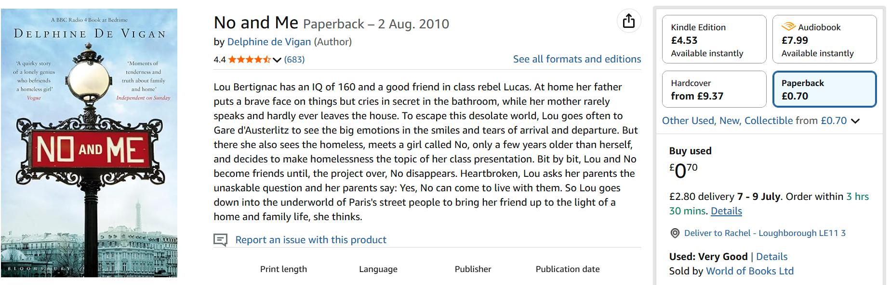
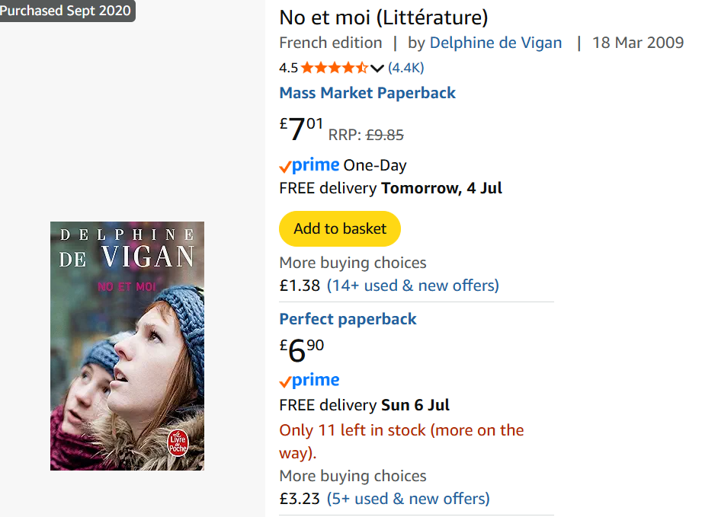

You will also need to revise in preparation for Paper 1. Your results will provide an additional basis for predicted grades for UCAS. Go through vocab and tenses. Watch some French language films or series, try listening to some French radio or podcasts.

In addition, we would like you to do a little research of your own to gather some pertinent facts, statistics, examples, names etc to show some deeper knowledge of France and the francophone world.
You ought to aim for three or four pieces of information per topic. It would be a good idea to use index cards to record this information which should be in French.

A Level
- une société diverse
- le multiculturalisme
- l’influence de la France dans le monde
- la vie en France pour les marginalisés
- comment on traite les criminels
- la prison: prévention, réhabilitation et réinsertion
- la politique
- l’Union européenne a-t-elle un avenir?
- les manifestations et les grèves
- les syndicats
- la politique et l’immigration

Try to get into the habit of reading or listening to the news in French, for at least 5 minutes two or three times a week. Some suggestions below. Can be downloaded as apps.
