A level Sociology
Introduction to
Sociology*
(Transition work)



Name: ........................................................................................

Teacher: .....................................................................................

* This transition work has been designed to suit those who have and those who have not studied Sociology at GCSE level. For those who have not done Sociology before, there is a lot of information and links for you to begin ‘bridging the gap’ between those who have studied Sociology before (please do not be put off if you have not done Sociology before. Whilst you may feel you have a lot of work to do to begin with, you will soon be ‘caught up’ with those who have. For those who have completed Sociology before, this transition work will serve as a recap of the GCSE and will contain sociological research and evidence to begin building on what you already know.
What is sociology?
Sociology, put very simply, is the study of society (a group of people living together in a more or less ordered community). Sociologists are interested in how societies work and the ways in which individuals, groups and institutions are interrelated.

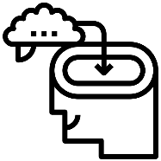 New to Sociology? | Watch this:  https://www.youtube.com/watch?v=TFdUtCAXAUM  (or type in ‘what is Sociology’)  [This video will give a brief overview of what Sociology is. There are other clips to view on YouTube alongside this if you wish to view them]

Sociology involves studying core ‘themes’ that are linked in with the topics we study during the A level course:

Core theme A  Culture, Socialisation and Identity | Core theme B  Social Differentiation, Stratification and Power
In sociology, we look at institutions such as the family, the education system and religion and ask questions about their structure and the effect that they have on individuals and on society as a whole.  We are also interested in areas of social concern such as crime, divorce and poverty, and try to explain why these issues occur and how they affect society and individuals. | The important issue of inequality is a key focus in sociology, and sociologists look at how factors such as social class, gender, ethnicity and age can affect an individual’s chances in life.

This transition work focuses on core theme A. The introduction weeks of the course will focus on core theme B.

These core themes will be studied and assessed through the following topics:

Year 1 | Year 2
- Families & Households  - Education  - Research methods | - Beliefs in Society  - Crime & Deviance  - Theory & Methods
TASK
At Rawlins, we follow the AQA specification.

CORE THEME A (Culture, Socialisation and Identity)

TASK:
Read and revise the ‘Introduction to Sociology’ content in order to prepare for an in-class test to assess your knowledge and understanding of ‘culture, socialisation and identity’ (you will be notified of the assessment date during your first lesson).

CORE THEME A: Culture, Socialisation and Identity

CULTURE
The word ‘culture’ is used in different ways in society. It is often used to refer to artistic and intellectual activities e.g. theatre. However, sociologists tend to use the term in a more general way to refer to the ‘way of life’ of a particular society.
Sociologists tend to consider the whole system of behaviour and beliefs of a society or group, which includes knowledge, language, faith, art, music, fashion, morals, laws, customs, traditions, lifestyle and more. Culture is very varied across the world – there is ‘cultural diversity’.

New to Sociology? | There are lots of documentaries and clips online that demonstrate differences in and the importance of culture.    Search for:  - Hamar tribe  - Suri tribe  - HSBC – culture adverts

Norms and values
The ‘norms’ and ‘values’ make each culture distinctive from each other:
- Values – these are beliefs that a society sees as important and accepted by most people. These are things we believe in, for example, in the UK we value life, honesty, loyalty, hygiene, family etc.
- Norms – these refer to expected patterns of behaviour that are based on the values of our culture. For example, in the UK the norm is to wear clothes in public (based on the value of modesty), we eat food with a knife and fork (based on the values of manners and hygiene) and we tend to queue a lot in our culture (based on values of order, politeness and fairness).
New to Sociology? | Think about the norms and values for the following activities, or one of your own:  - Going to the cinema  - Going out for a meal  - Going food shopping  - Going to a funeral  Challenge:  - Take one example from the list above and think about what happens if individuals ignore these norms or values. What are the consequences?

All norms and values are relative. That means they are not fixed and the same for all people in all situations. For example, wearing clothes is the norm in our culture (in the UK) when out in public but is not a norm when in the shower! Norms and values can change over time e.g. it was a norm to smoke in pubs and many restaurants before 2007 but has since become illegal here and more and more deviant.

  Key  research | Sex and temperament in three primitive societies – Mead (1935)
 | Margaret Mead (an American anthropologist) studied several tribal cultures in Samoa and New Guinea during the first half of the twentieth century. She looked at male and female behaviour and gender role expectations in different tribes. She found that gender roles varied across cultures. For example, in the Arapesh tribe – both males and females were gentle and cooperative. In the Mudugumor tribe, both genders were violent and aggressive. Interestingly, in the Tachambuli (now spelled Chambri), male and female roles are almost the opposite to what is expected in the US and UK. The women are dominant and aggressive and do not have much involvement in childcare whereas the men are timid, emotionally dependent and spend most of their time adorning (decorating) their bodies. Aggressive men are seen as ‘abnormal’.
Status & roles
When we talk about a person’s status we are referring to their position in society and the amount of prestige that this position gives them. So you as a student in a school or college have a particular status. When you go home you move into different statuses – a son, a daughter, a sister or a brother for example. The most common places we get our status from are jobs, family, education, social class and gender.

There are two main types of statuses in society: ascribed and achieved. An ascribed status is that fixed at birth by our social characteristics and is something we cannot change easily. Achieved status is down to a person’s own achievements and efforts. This is typically done through gaining educational qualifications and a professional career. In a society based on this kind of status it will be relatively easy to change the position you have been born into and there will be lots of opportunities for movement between status groups.

Along with every status that a person has there is an accep ted set of norms. So in the status position of a teacher, certain norms of behaviour are expected. All the norms that are associated with a particular status position are called a role. A role is a part that we play which has expected and acceptable behaviour associated with it. For example a doctor. A person playing this role is expected to act in a particular way, to follow expected norms of behaviour. These are linked to the fact that this role is high status. So we expect a white coat, an air of authority, the ability to listen to patients and to speak knowledgeably and politely. We do not expect someone to swear or burp, or listen to an iPod when we are playing the role of a doctor!

We do not just play one role in an average day; most of us have many roles that we regularly switch between, each one bringing with it its own set of norms. This playing of more than one part is known as having multiple roles. Sometimes, these different roles may clash, for example a boy may play the roles of son, brother, boyfriend, student, part-time waiter, friend and footballer. These are his multiple roles. But what happens when he gets in from school and has homework to do, a girlfriend who wants to go to the cinema, a football match to play, a shift in the local restaurant, a mother who wants him to babysit for his little sister and a group of friends who want him to go down to the local youth club? He clearly cannot do everything and so has decisions to make because the roles that he plays have come into conflict with one another. When this happens it is simply called role conflict.

New to Sociology? | Do the following people have ‘achieved’ or ‘ascribed’ roles?:  - Prince Charles  - Wayne Rooney  - Richard Branson  - Cheryl Cole  - Boris Johnson  (Answers are at the back)

SOCIALISATION
Socialisation is the process though which children learn to be ‘effective’ members of society. This process refers to the way older generations (grandparents, parents and others in society) pass on core values, beliefs, norms and traditions (culture) of society from one generation to the next. The process of socialisation and our culture help shape the identity of individuals who make up society.

Nature vs nurture
There has been a long-standing debate about whether our behaviours are a result of nature (natural and innate or inborn) or nurture (our upbringing in society). For example, are we born aggressive or do we learn to be aggressive? Are we born gay or do we learn to be gay? Are we born intelligent or do we learn to be intelligent? Are we born masculine/ feminine or do we learn to be masculine/ feminine? Etc.

New to Sociology? | There is a vast amount of different types of evidence and examples used in this key debate:    - Twin studies – e.g. type in ‘nature and nurture: the study of twins’ into YouTube.  - Feral children - Type in ‘Wild child: The story of feral children’ into YouTube and watch one of the case studies of feral children (or the whole documentary if you are interested). Alternatively, type in ‘Oxana Malaya’; ‘Genie’; ‘Kamala & Amala wolf children’; ‘Isabel the chicken girl’ and find out about one of these case studies.  - Experiments – See ‘Dr money and the boy with no penis’ into YouTube

The process of socialisation is divided into two stages: |  | ‘Agents’ of socialisation
Primary socialisation | the first and most important stage of learning | ‘family’
Secondary socialisation | the continuation of learning | ‘peers’, the ‘media’, ‘Education’, ‘religion’, ‘workplace’ etc

Agents of socialisation
Family
The early years are very important (0-5 years old). Children learn from their parents through imitation e.g. copying the way parents talk and behave at the dinner table. Children see parents as role models. Children learn acceptable and non-acceptable behaviour through trial and error and parents may use sanctions (positive and negative) to encourage and discourage behaviours.

Key  research | Gender roles (Ann Oakley)
A famous study that looked at the role of the family in terms of socialisation was conducted by Ann Oakley in 1981. She found that children were clearly being taught how to be girls and boys by their parents through a number of different means.
- Manipulation – this is when parents encourage certain behaviour seen as normal for either a girl or a boy, and discourage any behaviour associated with the opposite sex. So, for example, girls might be encouraged to play with dolls and boys will not.
- Canalisation. This is when parents push their children into either male or female roles. This is typically done through the toys which the children receive and the activities they engage in. A good example would be little girls playing with toy kitchens, preparing them for their future role cooking for a family. The way that parents talk to their children will also reinforce gender norms and expectations, with such phrases as ‘little princess’ and ‘brave little soldier’. Oakley’s study emphasises just how important the family can be in socialising children into their expected gender roles.

Key  research | Toxic childhood (Sue Palmer)
 | Sociologist Sue Palmer argues that parents use electronic technologies such as television, computer games and the internet (secondary agents of socialisation) as alternatives to traditional parenting practices (primary agents). Instead of spending quality time with their children and reading them stories, Palmer claims parents too often use television, electronic games and junk food to keep them quiet. Children are therefore deprived of a traditional childhood and family life. She claims the effects are negative and cause social problems, and that every year children become more antisocial. They are less able to learn, enjoy life and thrive socially because of these trends.

Peers
These are people of a similar age and characteristics as us. This can refer to friends but also those wider than friends. This is an important ‘agent’ of socialisation during school years as you spend so much time with your peers. You learn what is acceptable and desirable in order to ‘fit in’ (known as conformity).

Key  research | Peer groups in the classroom (Skelton & Francis)
 | Skelton and Francis (2003) looked at peer groups in primary schools – for example, in the classrooms and in the playground. Play was very gendered, with boys dominating the space and girls taking part is separate activities, such as skipping.

Education
At school, everyone learned a formal curriculum e.g. English, Maths and Science etc. Sociologists argue that we also learn an ‘informal’ or ‘hidden curriculum’ as well. This refers to the norms and values you learn (that you are not ‘examined’ on. For example, to arrive punctually, respect teachers etc. There are ‘sanctions’ in school for those who disobey.
- Gender roles - can be transmitted and learned through the unofficial hidden curriculum in schools. Evidence suggests that some teachers still have different attitudes to male and female students. At the back of their minds there may still be the assumption that males are destined to be breadwinners, whilst girls are destined for domesticity. This may lead to different careers advice and work experience placements. Boys are still more likely to be found in practical, computing and financial work and girls in office jobs, caring for others and health and beauty. Behaviour in the classroom may also be treated differently depending on whether the student involved is male or female. Boys are almost expected to be a little disruptive in class, to need nagging to do their work This may mean that teachers are more tolerant of such behaviour in boys than they are in girls, so if girls do this they will be punished more harshly than a boy would. Since equal opportunities legislation has been introduced, sexism in school books has declined rapidly. However, representations of girls and boys in these books still often fall into distinct gender roles. You are more likely to see boys playing outside and dads off to work, leaving behind the housewife mums whose daughters help out with the washing up! Finally, there are still big differences in the subjects males and females choose to study. Whilst it is up to the individual student what subjects they choose, most are still influenced by their parents, teachers and peers. Girls are more likely to be found studying the social sciences, languages, health and social care, textiles and home economics. Boys on the other hand, are more likely to choose PE, sciences, ICT, resistant materials and electronics. It is clear that schools are a major force when it comes to gender role socialisation.
Key  research | ‘Double standards’ (Sue Lees)
 | Research by Sue Lees (1993) found evidence of double standards in operation when it came to sex. Boys were proud of and praised for their sexual conquests, whereas girls were judged negatively as ‘slags’ and ‘slappers’ if they had sex outside a long-term relationship. Interestingly, these insults aimed at females were just as likely to be given by other girls as they were by boys.

Media
This is of growing influence and importance in society today. Use of the media is ever increasing e.g. internet, mobile phones, games, TV, magazines etc. We may be socialised and influenced by the media through the way social groups are represented (or shown) for example men may be more likely to be shown as aggressive and strong compared with women (as this is more stereotypical).

Key  research | Bulimic society – Young (2007)
 | Young (a British criminologist) argues that the media is partly responsible for criminality. He argues that the media has created a ‘bulimic’ society – one with constant hunger and desire to binge on everything and anything. Even those without much money are hooked on brands such as Gucci, BMW, Nike and watch TV for 11 hours per day – worshipping success, money, wealth and status but are excluded from attaining this. There is a culture of ‘get rich or die trying’ and Young explains that this may explain criminality among young and deprived youths.

Key  research | Bobo doll – Bandura (1963)
 | Watch the video for a summary of the research: https://www.youtube.com/watch?v=zerCK0lRjp8&feature=emb_logo

Religion
Some argue that religion is becoming less and less important in a more secular (non-religious) society – particularly in some parts of the world and for some groups of people. However, others have argued that many of our norms, values, customs and beliefs stem from and are based on religion and so we may be more influenced by religion than we realise. Attitudes towards divorce, homosexuality, abortion, euthanasia etc. are influenced by religious views to an extent.

Key  research | Religiosity – Modood and Berthoud (1997)
 | In a survey of young people, Modood and Berthoud found that 67% of Pakistanis and Bangladeshis saw religion as ‘very important’ compared with only 5% of white British youths. Those individuals raised in a Muslim, Hindu and Sikh families may feel that religion has a stronger influence on their norms and values.

Workplace
This is a key agent of socialisation for adults in particular and the concept ‘resocialisation’ is used to refer to new sets of norms and values that individuals learn when they start new jobs. This can be split into:
- Formal socialisation – workplaces have a code of conduct e.g. acceptable dress codes, behaviour and expectations. This is usually enforced with formal sanctions e.g. formal warning or being fired. There are also positive sanctions such as pay rises and other awards such as ‘employee of the month’.
- Informal socialisation – peer groups in the workplace often make it very clear what is and is not expected. For example, if employees are do not speak to others in the way that is expected or ‘suck up’ to the boss then they are likely to be given the silent treatment, for example. Some use the term ‘canteen culture’ (Waddington, 1999) to refer to the norms and values that people are expected to follow in an organisation.

Social control
All the agents of socialisation teach people what is expected of them in society. But society needs to make sure that we follow these norms and values, this is done by social control. One way of doing this is by having a system of rewards and punishments ready for use. Sociologists refer to punishments as negative sanctions and these are intended to deter people from doing the wrong thing in society, e.g. go to prison.. Rewards are the opposite of this process and are called positive sanctions. This time the aim is to encourage certain acceptable and desired behaviours to continue e.g. getting a postcard for you r school work.

Sanctions can be applied by an official group of people, such as a court or a person in authority. When this happens we call it formal social control. These agents typically have a lot of power and influence and are backed by written rules and laws. Key agents of formal social control are the police force, the courts, the prison service and the army. The main purpose of these agents is to control and regulate social behaviour.

Sanctions can also be applied informally, this is informal social control. Here there are unlikely to be written rules and instructions; instead the control is far more likely to happen as a normal part of everyday life. For example, parents stopping pocket money, friends showing their disapproval etc.

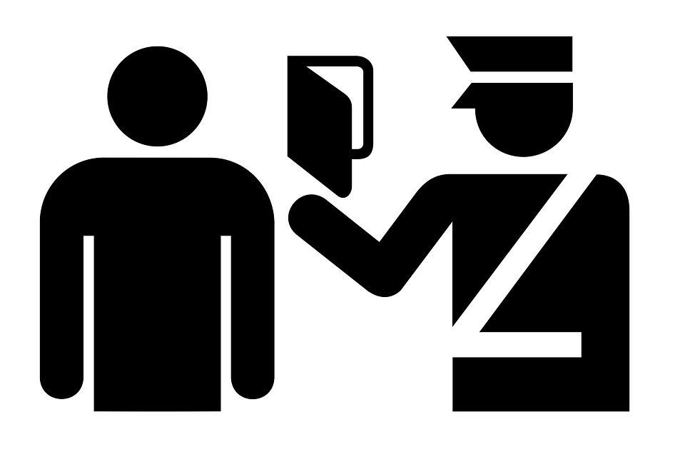

IDENTITY
Identity is often defined as how you see yourself.

Think about the question: ‘Who am I’?

When answering this question, you may have identified yourself as a member of various social groups (e.g. gender, age, ethnicity etc.) or perhaps in terms of things that are personal to you (e.g. name, personality traits, accomplishments etc.).

Shaping social identity
Your identity is a product of all of the experiences you have had through socialisation. It is formed by the agents of socialisation (family, education, peers, religion, workplace etc.).

Some see parts of your identity as fixed such as gender, social class, age and ethnicity whereas others see this as more of a fluid and active process. These days we tend to develop and construct our own identities. The media (an agent of socialisation) is important in helping us choose what to buy and wear and how we choose to look.

New to Sociology? | Watch the following:  - Type ‘orange – I am everyone’ into YouTube.  - Think about which agents of socialisation have had the biggest impact on your identity. Rank them in importance (Family, Media, work, peers, education, religion).

  Key  theory | Postmodernism
 | Postmodernist sociologists believe that today we have greater choice in our identities than ever before, as they become less and less fixed. Take women, for example. In the not too distant past a female’s identity was defined as housewife and mother. Some women still choose this identity today, but the point is that now they have a choice. Many women how create different identities through their choice of career or decision to remain childless. It is the same with ethnicity; none of the old rules apply. So today it is not unusual to see an Asian female dressed in jeans and a baseball cap, or a Geordie-speaking Sikh, wearing a turban and a sovereign ring.

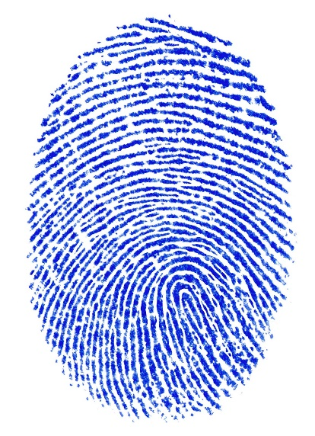

Some key terms

Values | General ideas about what is right and wrong, the correct ways of behaving and what is considered important and worthwhile.
Socialisation | The process of learning the correct behaviour, norms and values in a society; this can be either primary or secondary.
Agents of socialisation | The places or groups of people responsible for teaching individuals correct norms, values and behaviour.
Identity | How we see ourselves and how others see us.
Postmodernism | A sociological theory associated with changes in society from the 1990s onwards.
Status | The amount of prestige a person’s position in society gives them.
Ascribed status | Your position in society that is based on the social characteristics you were born with and is difficult to change.
Achieved status | Your position in society that is earned by your own efforts and achievements.
Role | A part you play that is associated with particular norms and expectations.
Multiple roles | Playing more than one role.
Role conflict | Where the demands of one role clash with the demands of other roles played.
Culture | The whole way of life of a society.
Culture diversity | Differences between cultures.
Subculture | A smaller culture within a culture with its own set of norms and values.
Manipulation | Parents encourage children to behave be in a way that is seen to be appropriate to their gender.
Canalisation | Parents give children gender-specific goods that are considered the norm for their gender, dolls for girls and not for boys, for example.
Hidden curriculum | The norms and values that schools teach students through day-to-day school life, not part of the formal timetable.
Social control | The methods used during the socialisation process to make sure individuals conform to the expected and acceptable norms and values in society.
Negative sanctions | Punishments used to prevent unacceptable behaviour.
Positive sanctions | Rewards used to encourage acceptable behaviour.
Formal social control | Written rules and laws enforced by powerful agents such as the police and courts.
Informal social control | Controlling people’s behaviour using informal methods in everyday situations.
Norms | The unwritten rules of society that determine acceptable behaviour.
Relativity | Specific to a particular situation, social group or society, not general.
Patriarchy | a society dominated by males, where they have more power than women.
Sexuality | our sexual behaviour and choice of sexual partners
Stereotype | a generalised and simplistic view of a group of people which ignores individual differences. They are often negative – women are bad drivers and blondes are bimbos are two examples of gender stereotypes that you may have come across.
Femininity | the quality of acting in a way that a society deems is typically female behaviour.
Masculinity | the quality of acting in a way that society deems is typically male behaviour

Sources for wider reading
- https://hecticteachersalevelsociologysite.wordpress.com
- https://www.s-cool.co.uk/a-level/sociology
- https://thesociologyguy.com

Answer to activity on status and roles:
- Prince Charles – ascribed (born into royalty)
- Wayne Rooney – achieved (worked hard to achieve success – although some would argue that sporting ability has a genetic link too)
- Richard Branson – achieved (success achieved through hard work)
- Cheryl Cole – achieved (through working hard – although could singing ability be linked to genetics?)
- Boris Johnson – BOTH (he has worked hard to become prime minister, however, he was also born into a very privileged family and went to a top public school)

We look forward to seeing you after the summer

