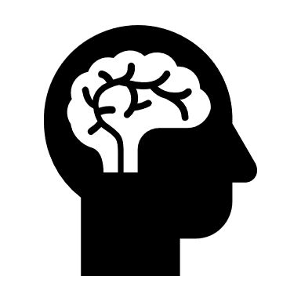
TASK 1: PSYCHOLOGY BRIDGING WORK: BIOPSYCHOLOGY

- Revise YR 12 Biopsychology content
- Nervous system
- Neurons and the process of synaptic transmission (incl inhibition and excitation)
- Endocrine system
- The fight or flight response

- Localisation of Function - resource:
Create a resource to explain the structure and functions of the brain.
You need to know WHERE of the below areas are and and WHAT they do. This can be as creative as you wish (e.g. Display, poster, cake, model, sculpture etc)*

Terms/areas you MUST include/know for your return in YR 13
- Left and right hemispheres
- The four lobes (frontal, temporal, occipital and parietal lobe)
- The corpus callosum
- Broca’s area
- Wernicke’s area
- Motor, visual, auditory, somatosensory cortex

You will need all of the above terms/content for your Year 13 Biopsychology module (see the attached section from the revision guide to support our learning.
BIOPSYCHOLOGY ASSESSMENT: On the week of the school bridging work deadline, you will have an assessment (knowledge and application) to demonstrate your understanding of the biopsychology topic (including the new Localisation of Function content)
*NOTE: you will also be required to submit your ‘Localisation of Function’ resource on the bridging work deadline day.

