A-Level Chemistry – Year 1
Summer Task
What will be expected of you on your return………
Expectations when you arrive …….
It is imperative that you are organised when you return next year, one basic requirement when undertaking this course is that you are methodical and ALL notes are arranged in order. Your notes will be regularly checked next year by your teachers; ensuring notes are being made during home study. In order to help you achieve this, you should make a plan to organise your notes. Many students opt for ring binder style folder (as many notes will be made), but if you have an alternative idea that will allow your notes to be organised then great.
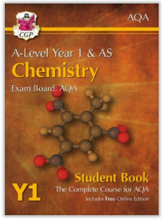
Optional: You will need the A Level textbook once you start your studies however this is expensive and you may wish to purchase from school once you have your results as we can get it at a discounted price.
Recommended:
https://www.cgpbooks.co.uk/secondary-books/as-and-a-level/science/chemistry/catb53-a-level-chemistry-for-aqa-year-1-as

- Product code: CATB53
- ISBN: 9781782943211
Task : Revision for introductory test.
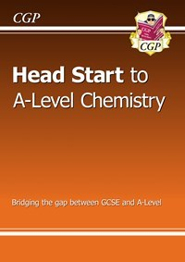
Your task is to revise for an introductory assessment this will be based on the topics below. These are all covered in the head start to A-level chemistry book. We would strongly recommend purchasing the book however the topics are all listed below if you would prefer to use youtube/internet resources.
Both the hard copy and kindle version are available through Amazon: https://www.amazon.co.uk/Head-Start-level-Chemistry-Level/dp/1782942807
Below is the list of topics that will be covered in your introductory assessment.
Subject
1 - Formulae, RFM and Balancing Equations
2- Moles
3- Reacting Masses
4- Atom Economy and percentage Yield
5- Concentration and Titrations including calculations
6- Conservation of mass
7- Reversible reactions including Le Chatelier’s principle
8- History of the atom
9- Revision and Extended reading
Chemistry Enhancement tasks
1 Read books
To be a better chemist it helps to see chemistry in its wider context. These books are a fantastic springboard into the wonder of chemistry and they are written at a level that assumes very little about your prior subject knowledge, but reading them will stretch you into areas that go beyond university level.
Strange Chemistry: The Stories Your Chemistry Teacher Wouldn't Tell You by Steven Farmer
The Selfish gene by Richard Dawkins
What If?: Serious Scientific Answers to Absurd Hypothetical Questions by Randall Munroe
2 Watch online videos
- There is some amazing Ted ed talks, here are two I recommend see links below:
- https://ed.ted.com/lessons/daniel-dulek-how-big-is-a-mole-not-the-animal-the-other-one
- https://www.ted.com/talks/rachel_pike_the_science_behind_a_climate_headline?subtitle=en&trigger=0s
- Or discovering more about the fascinating properties of the elements on the periodic table see links below: http://www.periodicvideos.com/
- https://www.open.edu/openlearn/science-maths-technology/science/chemistry/elements-the-periodic-table?LKCAMPAIGN=Google_grant_periodic&MEDIA=olexplore&gclid=Cj0KEQiA4qSzBRCq1-iLhZ6Vsc0BEiQA1qt-zseng4snkWJATgeJjv_yHaaIHDg5fCSs1ouSSocg2FsaAqkI8P8HAQ
3 Follow chemists on X
- Professor Andrea Sella
- Professor Lucy carpenter
- Dr Tim Gabriel
- Dr Jessica Wade We look forward to welcoming you to A-level chemistry!

