A LEVEL DANCE – COMPONENT 2: SECTION A

Read the following Guardian article ‘Rambert at 90’ and then answer the questions provided.
Rambert at 90: the ballet company that made British dance a homegrown hit | Rambert | The Guardian
Rambert at 90: the ballet company that made British dance a homegrown hit
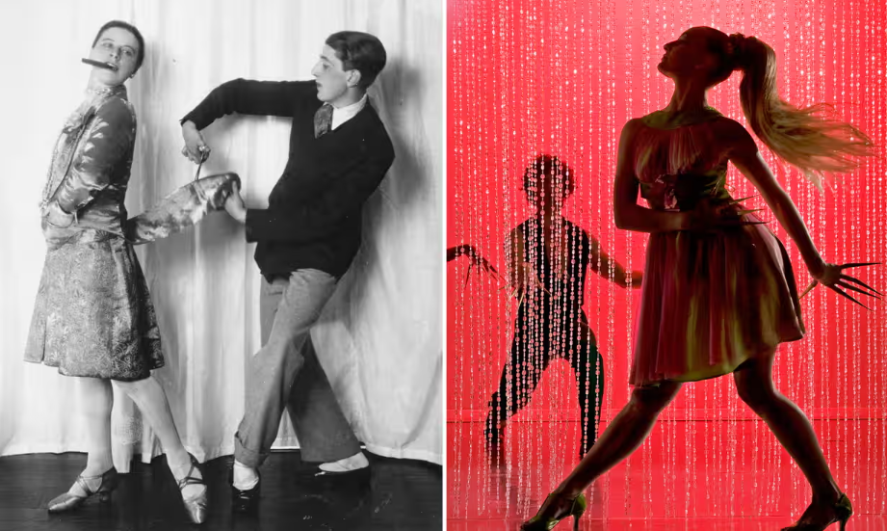
Rambert’s 1926 debut, A Tragedy of Fashion; and Cardoon Club, 2010.

The mould-breaking dance company is celebrating its ninth decade. We trace the nimble steps that took it from a raggle-taggle bunch of students to global name
Marie Rambert had no idea she was making history when she and her little dance troupe made their debut at the Lyric Hammersmith 90 years ago. Her raggle-taggle bunch of student dancers faced stiff competition in London that year: Diaghilev’s Ballets Russes were dancing two packed seasons, including the British premiere of Bronislava Nijinska’s monumental Les Noces, a glowing restaging of The Firebird, and the return of two of the company’s star ballerinas, Tamara Karsavina and Lydia Lopokova. Meanwhile, the Cochran revue boasted work by the great Leonid Massine.
Adding to Rambert’s troubles was the prejudice, still strong among the British public, that ballet was a foreign art form: Russian with a dash of Italian and French. A homegrown ballet company could only be an amateur aberration.
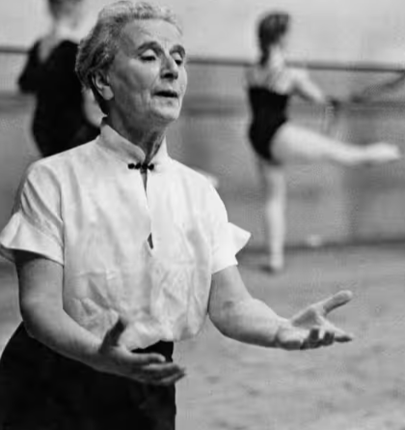 Marie Rambert teaches a class in Notting Hill Gate, 1957.
Still, Rambert had her advantages. A cosmopolitan Pole married to the British playwright Ashley Dukes, she had been attached to Diaghilev’s company before the war, so had her own sprinkling of Russian stardust. She was armed with a ferocious amount of personality: childlike, gushing enthusiasm combined with an autocratic style of command. And crucially, she had an eye for talent.
The company’s debut, A Tragedy of Fashion, was choreographed by a then unknown Frederick Ashton – a skinny, witty, sentimental youth who yearned to dance like Anna Pavlova but whose true gift lay in mimicking steps. Ashton’s ballet was a slight, self-conscious comedy, about a failed couturier who kills himself with his own scissors. But it deftly channelled the decade’s vogue for chic “lifestyle” ballets and came with some serious music and design.
A Tragedy of Fashion was greeted as a clever novelty – an “engaging little ballet” wrote the Observer – and it was Rambert’s instinct for the new that marked out her next decade, as the modestly named Ballet Club expanded into the more assertive Ballet Rambert. With no preconceptions about where or who to scout, she commissioned Antony Tudor (a student dancer who’d paid for his classes by clerking at Smithfield meat market), Andrée Howard (one of a tiny minority of women ballet choreographers) and the young South African Frank Staff.
In 1929, Rambert’s fortunes were given a tragic boost with the death of Sergei Diaghilev, and the disbanding of his company. British ballet fans had to look elsewhere for their dance, and British dancers, like the precociously talented Alicia Markova, elsewhere for work. Rambert profited from both – Markova would perform for her on and off until 1935, but soon came local competition in the form of the Camargo Society, a loose affiliation of dancers, choreographers, composers, designers and prominent ballet obsessives.
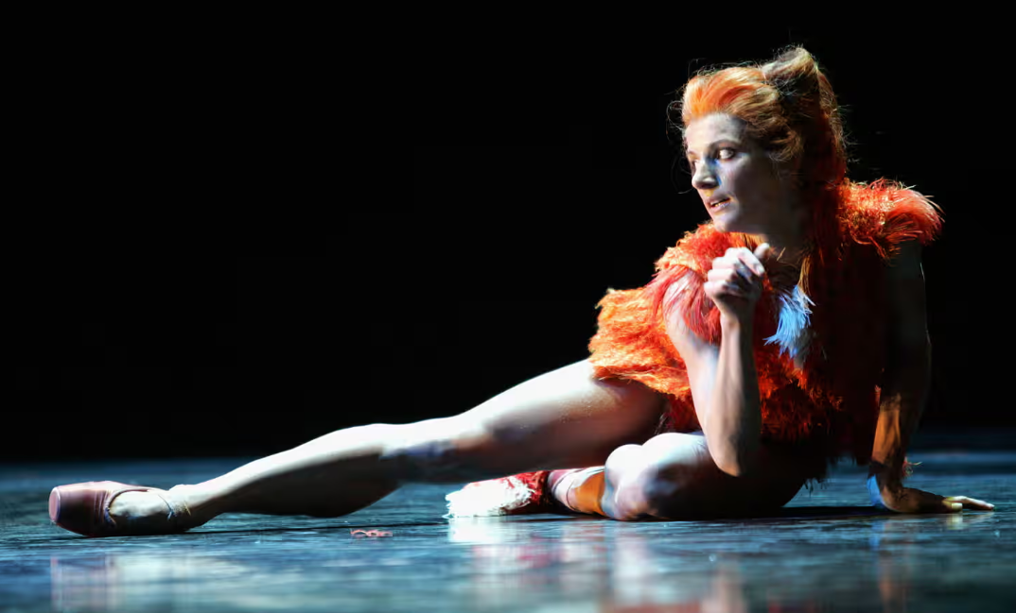
Pieter Symonds revives Lady Into Fox in 2006.

Rambert reluctantly aligned herself to Camargo, fielding dancers for the ad hoc seasons it presented. But she was rapidly outgunned by another member, Ninette de Valois, the formidably ambitious Irishwoman who, with the backing of the equally strong-willed Lilian Baylis, set up her own ballet company in 1931 at Sadler’s Wells.
Rambert and De Valois more or less divided the ballet scene of the 1930s. De Valois was building her own company on a bedrock of 19th-century classics, while relying on Ashton to help her create new repertoire. Rambert was still focused entirely on the new, and from her tiny, 150-seat theatre, the Mercury, she developed Tudor’s psychological masterpiece, Jardin Aux Lilas; Howard’s fashionably surreal Lady into Fox, and Frank Staff’s Peter and the Wolf.
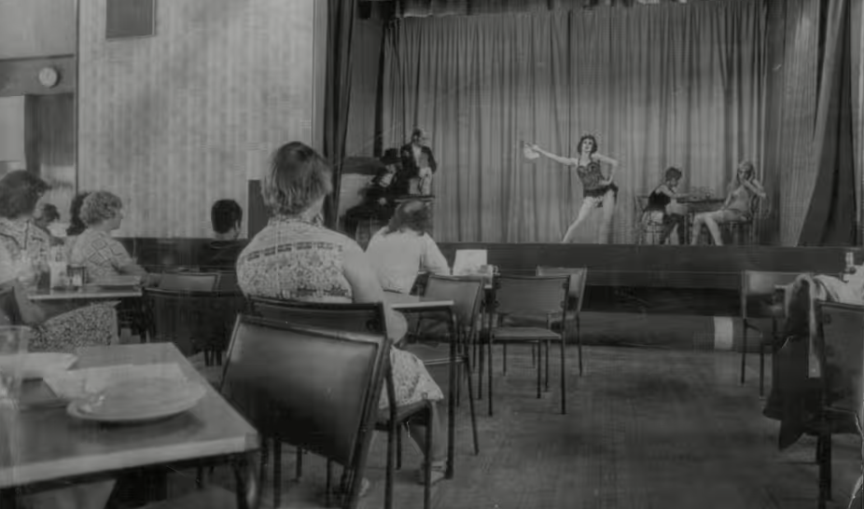
Ballet Rambert give a lunchtime performance at a Plessey electronics factory, 1975.

If Sadlers Wells could boast Margot Fonteyn as its new company ballerina, Rambert had the lively talents of Maud Lloyd, Diana Gould, Harold Turner and Hugh Laing. But the war changed everything. Male dancers were conscripted, Tudor and Laing left for America and, with the remnants of her company, Rambert toured the UK giving mini performances in factory canteens and garrison theatres.
During the austerity 1950s, public taste shifted towards the escapist fantasies of 19th-century classics. Rambert still commissioned new ballet but the company was mostly touring scaled-down productions of Giselle or Coppelia. Sadler’s Wells had grown into a monolithic rival, based at the Royal Opera House and from 1954, given the status of Britain’s national company, the Royal Ballet.

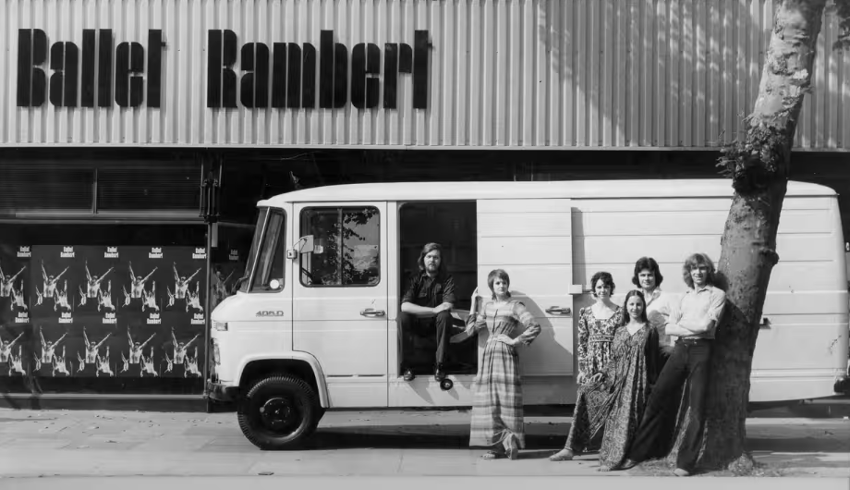
On the move … outside the Chiswick studios, 1972.

Yet an instinct for experiment and survival was deep in Rambert’s DNA. In 1954, the dance pioneer Martha Graham brought her company to London and Rambert made all her dancers buy a ticket. Sensing a rich new dance language, she agreed to let her principal choreographer, Norman Morrice, go to New York in 1962 to study the Graham technique. Four years later, Rambert accepted the time had come for her company to leave its ballet origins behind, and gave Morrice three months to transform Ballet Rambert into Britain’s first modern dance company.
That was half a century ago. Since then each of Rambert’s artistic directors has brought their own personality to the company. Under Morrice it was dominated by the Graham style – taut, athletically powered, symbolically burnished dance. A new force emerged with Christopher Bruce who developed a more lyrical, politically charged style, exemplified in Cruel Garden, a Lindsay Kemp collaboration saturated in death, sex and surrealism.
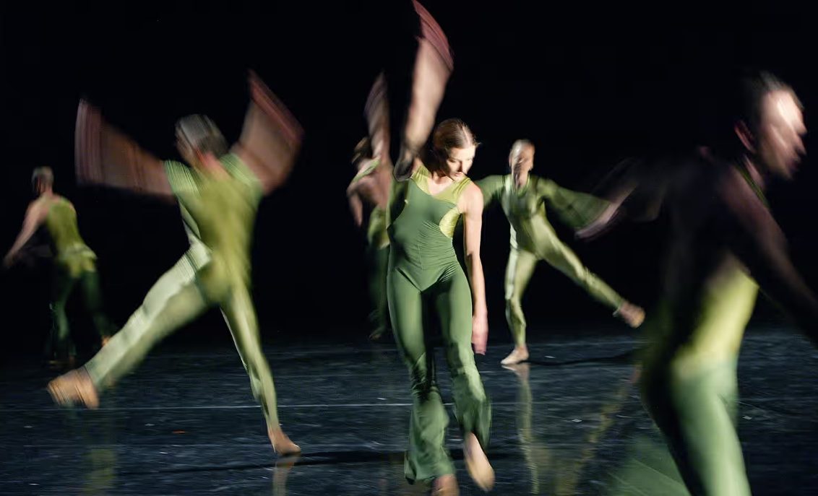
Instinct for experiment … 2004’s Swamp.

Under Richard Alston in the 1980s and 90s, Rambert Dance Company shifted towards an abstract, modernist aesthetic, inspired more by Merce Cunningham than Martha Graham. Alston’s own works were distinguished by startling design by artists Howard Hodgkin and John Hoyland, and contemporary scores by Nigel Osborne and others. The finest of Alston’s commissions was surely Swamp, a work of dark, thrumming dynamism created by Michael Clark.
Alston was succeeded by Bruce, and in 2002 Mark Baldwin took over. His directing style has been marked by a playful eclecticism, with works as varied as Wayne McGregor’s futuristic PreSentient; Javier de Frutos’s Cole Porter fantasy, Elsa Canasta; Kim Brandstrup’s sophisticated, emotion drenched Transfigured Night and Henrietta Horn’s lush and spiky Cardoon Club. Baldwin seems to favour British or British-based choreographers – a welcome proportion of whom have been women, like Shobana Jeyasingh and Didy Veldman – and new music, such as Gavin Higgins’s brassy score for Dark Arteries.
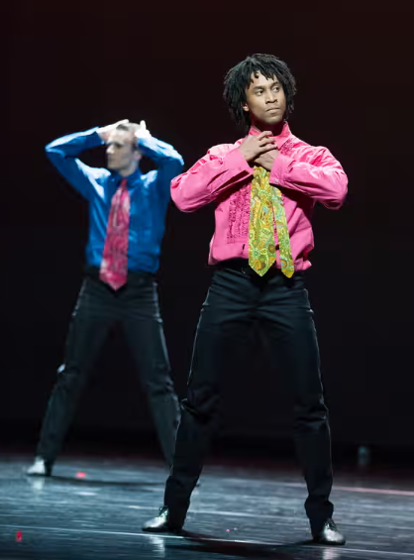 Miguel Altunaga, right, struts the stage in Rooster.
His tenure hasn’t been without controversy, disappointment, and a couple of duds. Like his predecessors Baldwin is criticised both for being too populist, and too out of touch. Rambert tours the UK, mixing crowd-pleasers like Christopher Bruce’s Rooster, with more cerebral works by younger choreographers like Alexander Whitley. Walking the Arts Council’s bureaucratic tightrope of “innovation” and “accessibility”, it has inevitably missed some steps. Since the Cunningham company disbanded, Rambert has become one of the main champions of the great man’s work. Two recent highlights have been the company’s revival of the glorious Sounddance and its organisation of a Cunningham-styled Event, with designs by Gerhard Richter and music by Radiohead’s Philip Selway. There have also been revivals of A Tragedy of Fashion and Lady into Fox.
I for one salute this embrace of the past – who else would be doing these projects? – but others argue that Rambert’s time and money would be better spent on creating new work and encouraging new choreographers. It’s a balancing act. The vast majority of contemporary dance groups operate within their own present moment, developing individual styles and audiences; thanks to the drive and spirit of Marie Rambert, this company has deeper roots; plus some of the world’s best dancers. It’s always surprising to me how many people recognise the Rambert name. If there’s a national brand in British contemporary dance, this is surely it.

TASK 2 - Comprehension:
Section 1 — Factual Recall
- Early competition — What major companies and productions were performing in London at the time of Rambert’s 1926 debut

- Public prejudice — What attitudes did the British public hold about ballet as an art form in the 1920s?

- Ashton’s debut — Who choreographed A Tragedy of Fashion, and how was it received?

- Key early choreographers — Which emerging choreographers did Rambert commission in her early years?

- Impact_of_Diaghilev — How did the death of Sergei Diaghilev in 1929 influence Rambert’s company?

Section 2 — Understanding and Interpretation
- Camargo_relationship — Why did Rambert reluctantly align herself with the Camargo Society, and what challenges did this create?

- Rambert_vs_De_Valois — How did Rambert’s artistic focus differ from Ninette de Valois’s during the 1930s?

- War_impact — What effect did the Second World War have on Ballet Rambert’s dancers and touring activity?

- 1950s_shift — Why did public taste move towards 19th-century classics in the 1950s, and how did this affect Rambert?

Section 3 — Contextual and Stylistic Analysis
- Graham_influence — How did Martha Graham’s visit in 1954 influence the company’s direction?

- Modern_transition — What steps did Norman Morrice take to transform Ballet Rambert into a modern dance company in the 1960s?

- Bruce_style — What characterises Christopher Bruce’s choreographic style, and which work from the article exemplifies it?

- Alston_era — How did Richard Alston shift the company’s aesthetic in the 1980s and 90s?

Section 4 — Critical Thinking & Evaluation
- Baldwin_eclecticism — What criticisms and strengths are associated with Mark Baldwin’s leadership of Rambert?

- Innovation_vs_accessibility — How does the company navigate the Arts Council’s expectations of “innovation” and “accessibility”?

- Revivals_debate — Should Rambert focus on reviving historical works or prioritise new choreography? Use examples from the article.

- National_identity — Why does the author argue that Rambert is “a national brand in British contemporary dance”?

